Target Break

By Josiah Milord

## Overview:

3D target-breaking game involves a first-person perspective, where players navigate a dynamic environment and aim to destroy 3D targets using a pistol. The game includes movement controls, shooting mechanics, and responsive target interactions, providing players with an engaging and challenging experience..

## Pitch:

The goal of the app is to provide an immersive and enjoyable 3D target-breaking experience, where users can navigate a virtual environment and aim to destroy dynamic targets using the pistol. The app aims to be especially effective by offering shooting mechanics, responsive target interactions, and an engaging first-person perspective, delivering a heightened sense of presence and entertainment. Users will navigate the environment, strategically aim, and shoot at targets as fast as possible.

## Basics:

Movement: Use the "W," "A," "S," and "D" keys to move forward, left, backward, and right.

Run: Hold the left "Shift" key while moving to run.

Jump: Press the "Space" key to jump.

Look Around: Move the mouse to adjust the camera's view.

Shoot: Left-click to shoot targets.

Change Scene: The cursor is unlocked, allowing interaction with UI elements, facilitating scene changes or other actions.

Crosshair: Indicates the aiming position on the screen, adjusting dynamically with the camera's movement.

## Events and Interactions:

**Sound & Effects**:

Gunfire Sounds: gunfire sounds for the weapon...

Target Interaction Sounds: Unique sounds when a target is hit or destroyed. Audio feedback for successful shots.

UI Feedback Sounds: Button clicks for menu navigation.

**Gameplay Mechanics:**

Scoring System: Counts the amount of targets that have been broken

Game Modes: Has two game modes the target range and inside of the city

### Flow diagram and menu sketches:

#### In words explain the game play flow

#### Flow diagram:

In a picture describe the gameplay flow

Flow diagram of game

#### 

#### Menu Sketches:

Put sketches of any UI menu

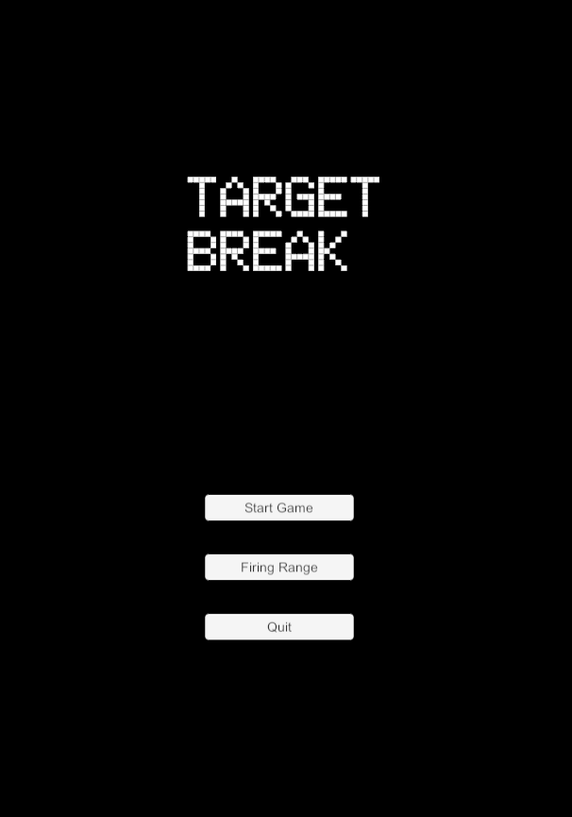

## Optimization:

To make the user experience more accessible / comfortable:

* Made sure to make sure that the colors didnt look to similar making the targets easier to see

Future Ideas

* Customizable controls allowing players to remap keys, making it accessible for individuals with specific needs or preferences.

Target Metrics:

Target a consistent FPS of 60 ensuring a smooth experience across various hardware configurations.

Speed improvements I made:

* Capped the frame rate to maintain a stable and smooth gaming experience.
* Utilized low-poly assets to reduce rendering complexity and improve performance.
* Limited lighting complexity to enhance speed and responsiveness.

## Publishing:

Icon:

Company Name:Milord Inc

Product Name: Target Break

Version: -- 2

Splash Image:

(not required)

## 

## Detail design

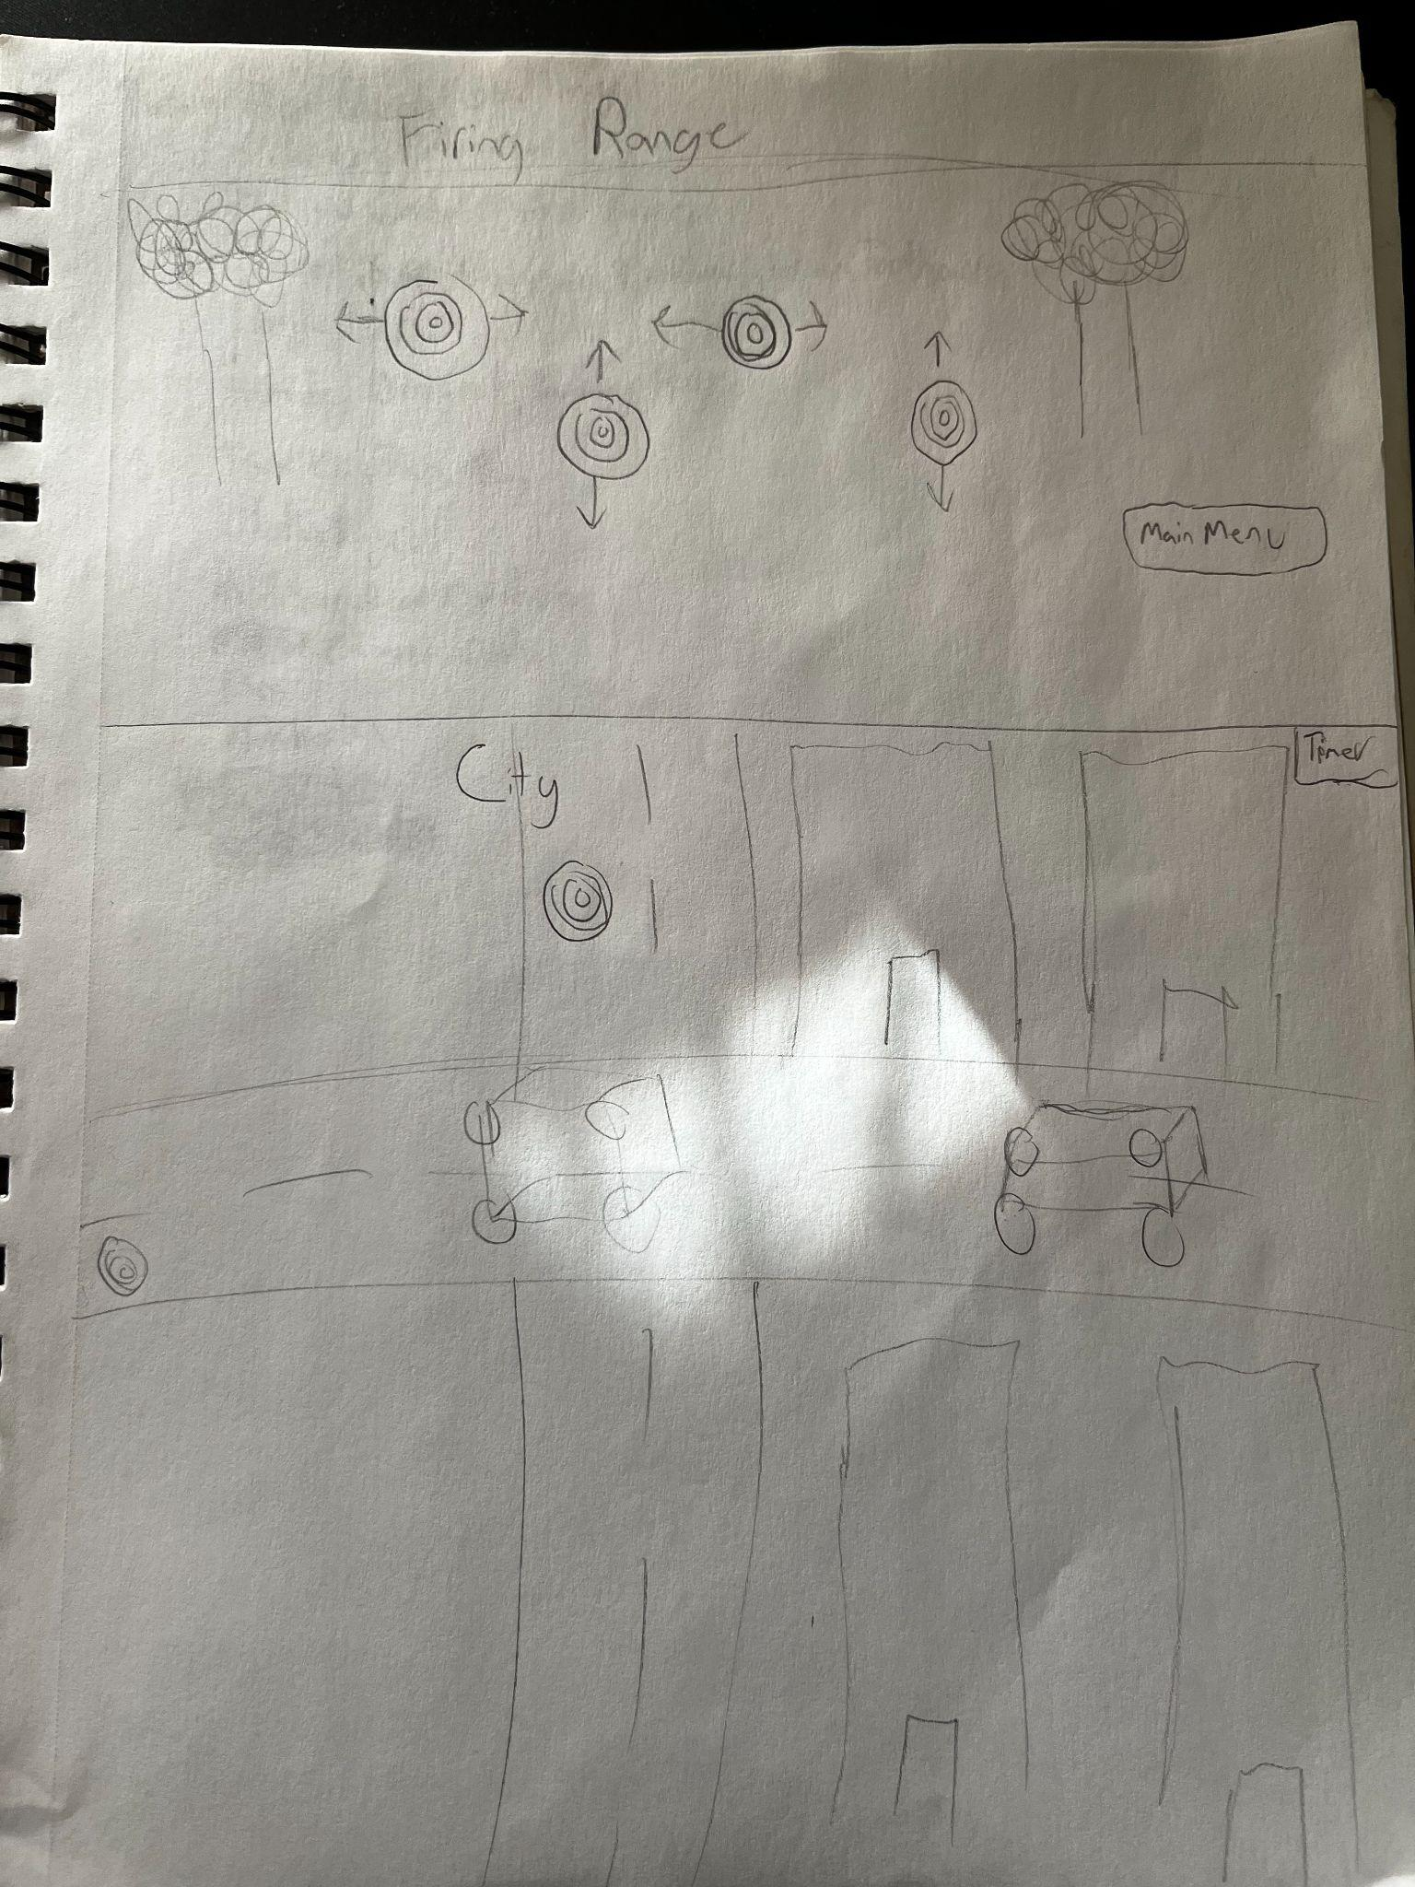

The fire range is a level where the player can test out the gun and how it aims in the game the settings are the same so it give the user a sense of familiarity with what they are doing.

The second level is the main game where the character is in the city he can move around the city freely however there are targets that he has to destroy to win the game

## Timeline:

**Sprint 1: (11/30)**

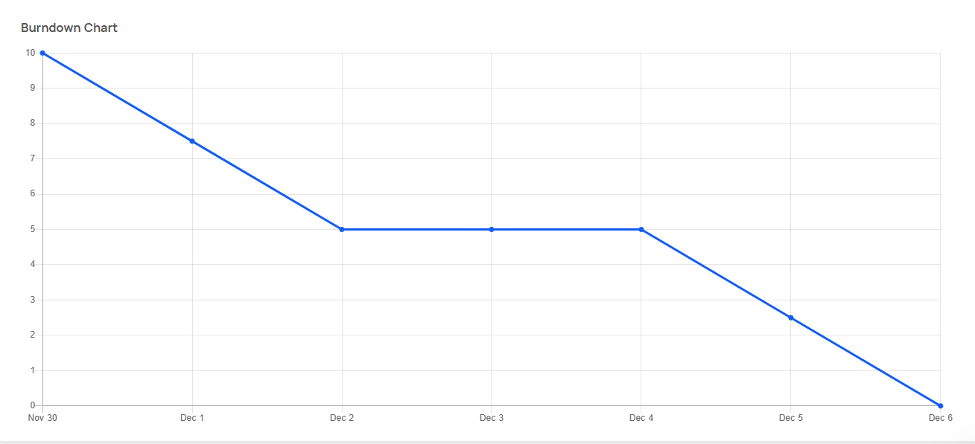

Burndown chart of sprint 1

For the first sprint the items that i wanted to work on was getting the map for the game and some basic character movement

**Sprint 2: (12/7)**

List items in your sprint

For this sprint i wanted to implement the moving targets and the firing range

Burndown chart of sprint 2

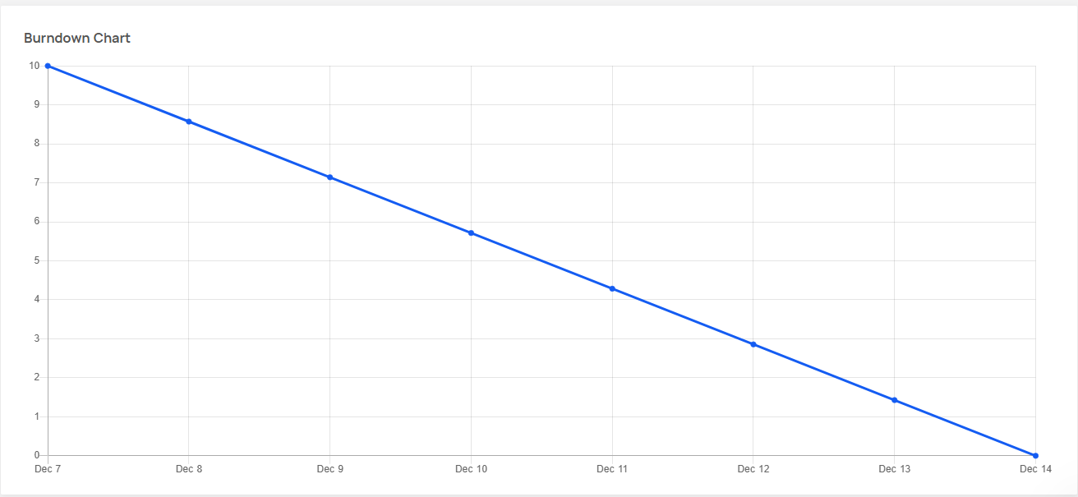

**Presentation Sprint: (12/14)**

List items in your sprint

For this sprint i didnt feel like the movement was fluid enough so i fixed the movement and tested any bugs that i had

Burndown of your sprint 3

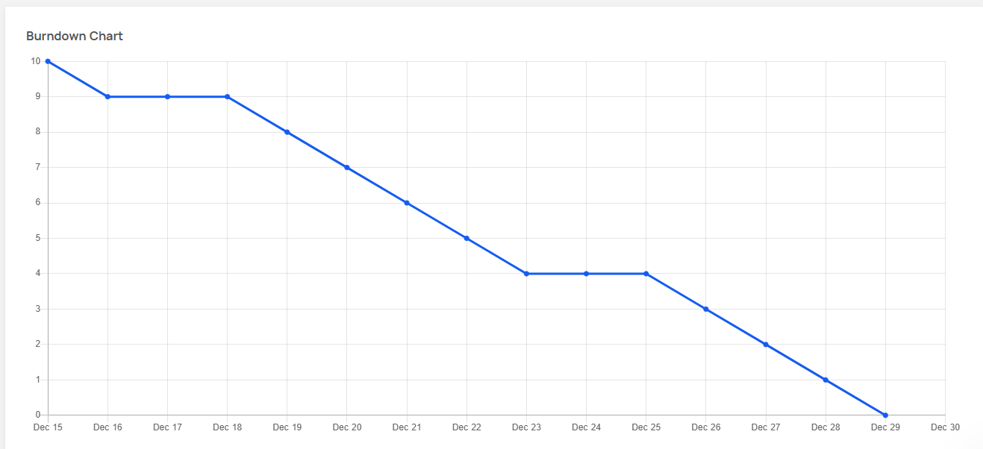

**Hope and Bugs:**

List all items that you would like to add

Customizable UI: Allow users to adjust UI elements' size, contrast, and color schemes for better visibility.

Colorblind Modes: Implement colorblind-friendly visual modes to enhance the gaming experience for players with color vision deficiencies.

List any bugs found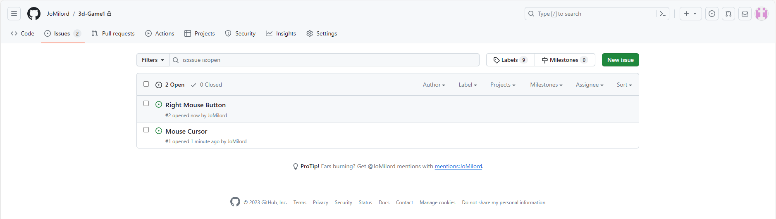

(Items in the Hope and Bugs section should be listed as “issues” - have a screen shot from your github issues section to show that you put them in)

## QA Test Scripts

Either put your QA test scripts for each feature of your game here, or have a link to the scripts

My QA scripts are in my game script some scripts print words to the console to see if it works

## Links

Github Repo:[Issues · JoMilord/3d-Game1 (github.com)](https://github.com/JoMilord/3d-Game1/issues)

Project Board:

Running Game or Release section link:

## List of items not made by me:

Al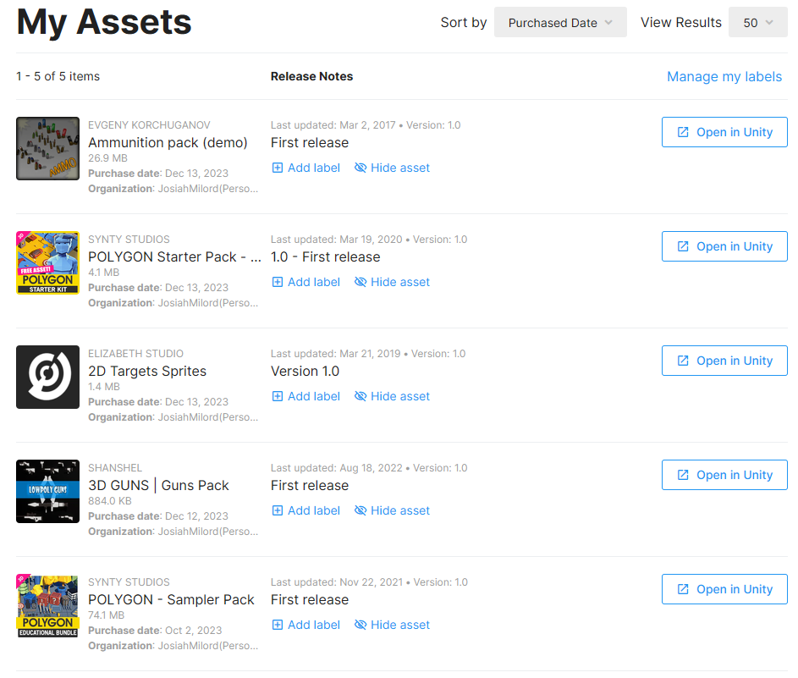

Also part of my player controller was from [Unity FPS Controller | Sharp Coder Blog](https://www.sharpcoderblog.com/blog/unity-3d-fps-controller)

## List of items made by me:

This section is not required, but feel free to make a list of all the things you made from scratch.

## Scripting

Here put a screenshot of the scripts that you wrote. After each screenshot, explain why you wrote this, what it does/how it works, and what it is used for.

The LoadSceneOnTab script

loads a specified scene when the Tab key is pressed. It uses Unity's SceneManager to facilitate scene transitions based on user input.

SC_FPSController:

The primary player controller script for a first-person shooter. Manages player movement, camera rotation, and gun handling. Includes features like jumping, running, and mouse-based look controls.

ShootingScript:

Handles shooting mechanics for the player. Uses raycasting to detect hits on targets, triggering appropriate actions..

WinGame:

Manages win conditions, tracking targets and time. Uses TextMeshPro for display.

Determines victory by counting target destruction and time.